

App User Guide


1. Main Page
- Main Interface Overview
- Main Components:
  - Top Navigation Bar & Left-Side Navigation Panel
    - Home
    - Project Updates
    - Admin
    - OneShape Search
    - Notification Settings
    - Recent Notifications
    - Chatbot
  - Main Menu Header
  - Option Selector Dropdown
- Instructions for the Navigation Buttons:
  - Home Button
  - Project Updates Button
  - Admin Button
  - onShape Search Button
  - Notification Settings Button
  - Recent Notifications Button
  - Chatbot Button

2. Project Updates Interface Overview
- Main Components:
  - Recent Updates Log
  - Navigation Buttons
    - Back to Main Menu
    - Next
- Instructions for Users:
  - Reviewing Updates
  - Navigating Between Pages
  - Utilizing the Log

3. Analysis of Project Updates Interface Overview
- Main Components:
  - Summary Section
  - Details of Last Update
  - Navigation Buttons
    - Back
    - Next
- Instructions for Users:
  - Reviewing the Summary
  - Understanding the Last Update
  - Navigating the Interface

4. Data Visualization and Analysis Interface Overview
- Main Components:
  - Navigation Buttons (Top of the Page)
    - Back
    - Home
  - Graphs and Charts (Data Visualization)
    - Changes by User
    - Actions per Document
    - Frequency of Actions
- Instructions for Users:
  - Interpreting the Charts
  - Navigating the Interface

5. Admin Panel - Upload JSON File Interface Overview
- Main Components:
  - File Upload Section
  - Upload Button
  - Navigation Button
    - Back to Main Menu
- Instructions for Users:
  - Uploading a JSON File
  - Navigating Back
  - Important Notes

6. OneShape Index Search Interface Overview
- Main Components:
  - Search Term Input Field
  - Search Button
  - Navigation Button
    - Back to Main Menu
- Instructions for Users:
  - Conducting a Search
  - Reviewing Search Results
  - Navigating Back
  - Tips for Effective Searching

7. Notification Settings/Personalization Interface Overview
- Main Components:
  - Notification Preferences
  - Save Settings Button
  - Navigation Button
    - Back to Main Menu
- Instructions for Users:
  - Customizing Notifications
  - Saving Your Preferences
  - Navigating Back

8. Recent Notifications Interface Overview
- Main Components:
  - Filter Options
    - Time Filter
    - Student Filter
    - Description Filter
  - Apply Filters Button
  - Navigation Button
    - Back to Main Menu
- Instructions for Users:
  - Filtering Notifications
  - Applying Filters
  - Navigating Back
  - Tips for Effective Use

9. Project Management Chatbot Interface Overview
- Main Components:
  - Chat Window
  - Message Input Field
  - Send Button
  - Navigation Button
    - Back to Main Menu
- Instructions for Users:
  - Interacting with the Chatbot
  - Sending Messages
  - Navigating Back
  - Using the Chatbot Effectively

10. Common Errors and Troubleshooting

-1 Main Page
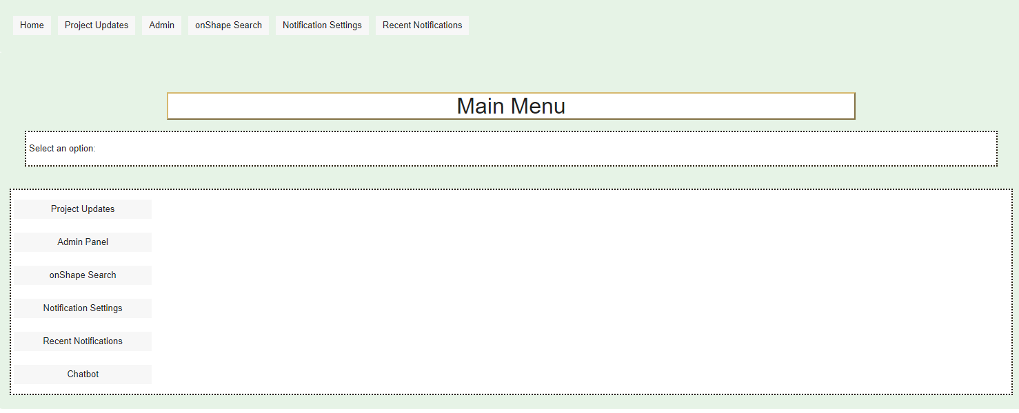

Main Interface Overview
This interface is the primary navigation hub of the application, allowing users to access different functionalities related to project updates, administration, searches, notifications, and settings.

Main Components:
- Top Navigation Bar & Left-Side Navigation Panel:
  - Home: Returns you to this main interface regardless of your current location within the application.
  - Project Updates: Allows you to view and manage updates related to ongoing projects, displaying every student's work with detailed information for each one.
  - Admin: Provides access to the administrative panel, where you can manage user permissions, configure system settings, and upload JSON files.
  - onShape Search: Lets you search for specific shapes or designs within the application and perform onShape Index Searches for words.
  - Notification Settings: Takes you to the notification configuration page, allowing you to personalize notifications for users and administrators, including email alerts and push notifications.
  - Recent Notifications: Displays the most recent notifications you’ve received due to the chosen student, including updates, alerts, and system messages.
  - Chatbot: Provides access to a chatbot for real-time assistance and inquiries, guiding you through the application or answering immediate concerns.
- Main Menu Header:
  - The "Main Menu" header clearly indicates the current interface you are in.
- Option Selector Dropdown:
  - Select an option: A dropdown menu that allows you to select a specific option to view or manage.


Instructions for the Navigation Buttons :
- Home Button:
  - Function: Returns you to the main menu interface.

  - How to Use: Click "Home" from any location within the application to return to the main menu.
- Project Updates Button:
  - Function: Opens the project updates interface.

  - How to Use: Click "Project Updates" to view detailed progress and information on every student's work.
- Admin Button:
  - Function: Accesses the administrative panel.

  - How to Use: Click "Admin" to enter the admin panel, where you can manage system settings, user permissions, and upload JSON files.
- onShape Search Button:
  - Function: Initiates a search for specific shapes or designs.
  - How to Use: Click "onShape Search" to perform a search, including onShape Index Searches for specific words.
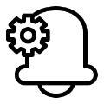
- Notification Settings Button:
  - Function: Opens the notification settings page.

  - How to Use: Click "Notification Settings" to personalize notification preferences for both users and administrators.
- Recent Notifications Button:
  - Function: Displays the latest notifications for each student separately.
  - How to Use: Click "Recent Notifications" to view the recent updates for each student, alerts, and system messages.

- Chatbot Button:
  - Function: Provides access to the chatbot.
  - How to Use: Click "Chatbot" to open a chat window for real-time assistance and inquiries.

2-Project Updates Interface Overview
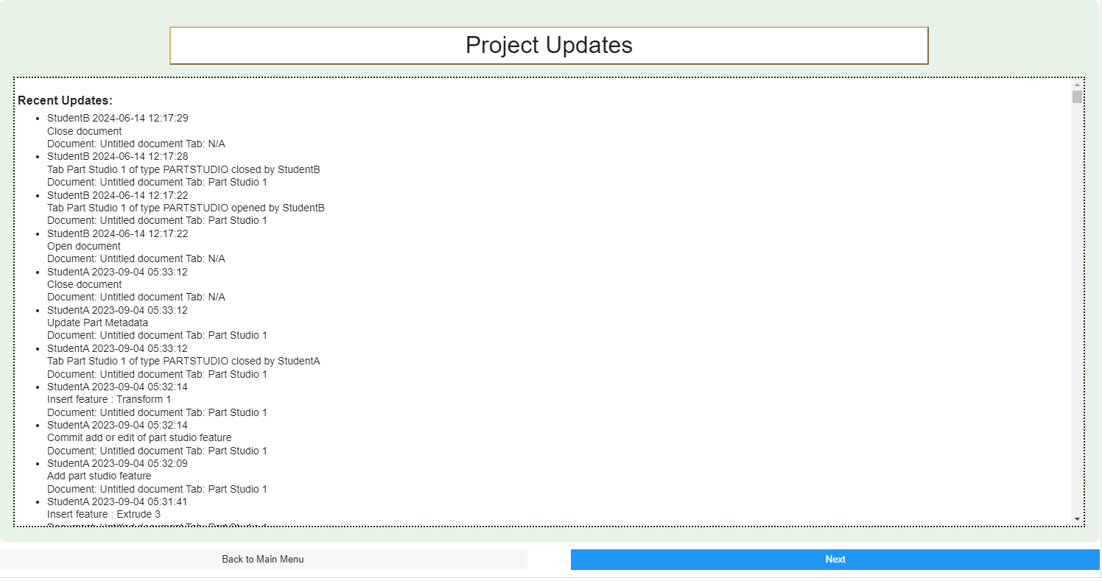

the "Project Updates" interface, which the user sees after clicking on the Project Updates button displays a detailed log of recent activities and updates related to ongoing projects. Users can review the actions taken by different students, including document edits, feature insertions, and metadata updates.

Main Components:
- Recent Updates Log:
  - Description: The central area displays a chronological log of recent project updates. Each entry shows the student's name, the time of the update, and a brief description of the action taken (e.g., opening or closing documents, adding features, or updating metadata).
  - How to Use:
    - Scroll through the list to view recent activities.
    - Each bullet point provides specific details, such as the document type, part studio, and the exact action performed.
    - This log is useful for tracking progress and understanding the sequence of changes made by different team members.
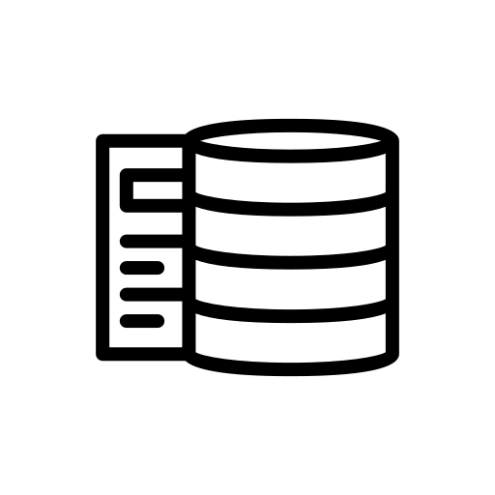
- Navigation Buttons:
  - Back to Main Menu:
    - Function: Returns you to the main interface from the project updates page.
    - How to Use: Click this button if you wish to go back to the main menu to select a different option or navigate to another section of the application.

  - Next:
    - Function: Allows you to proceed to the next page or step related to project updates.
    - How to Use: Click this button to continue to the next set of updates or related functionalities, ensuring you’ve reviewed the current updates before moving forward.

Instructions for Users:
- Reviewing Updates:
  - Start by carefully reviewing the recent updates log. Pay attention to the actions taken by different students, noting any significant changes or additions.
  - Use this information to stay informed about the progress and contributions of each team member.
- Navigating Between Pages:
  - Use the "Back to Main Menu" button to exit the Project Updates interface if you need to check something else or return to the main navigation hub.
  - Click "Next" to move forward in the updates, ensuring you’re following the sequence of changes across different time periods or stages in the project.
- Utilizing the Log:
  - This log is particularly useful for tracking changes and ensuring that no important updates are missed.
  - If any discrepancies or issues are found, use this log as a reference to identify when and by whom specific changes were made.

3-Analysis of Project Updates Interface Overview
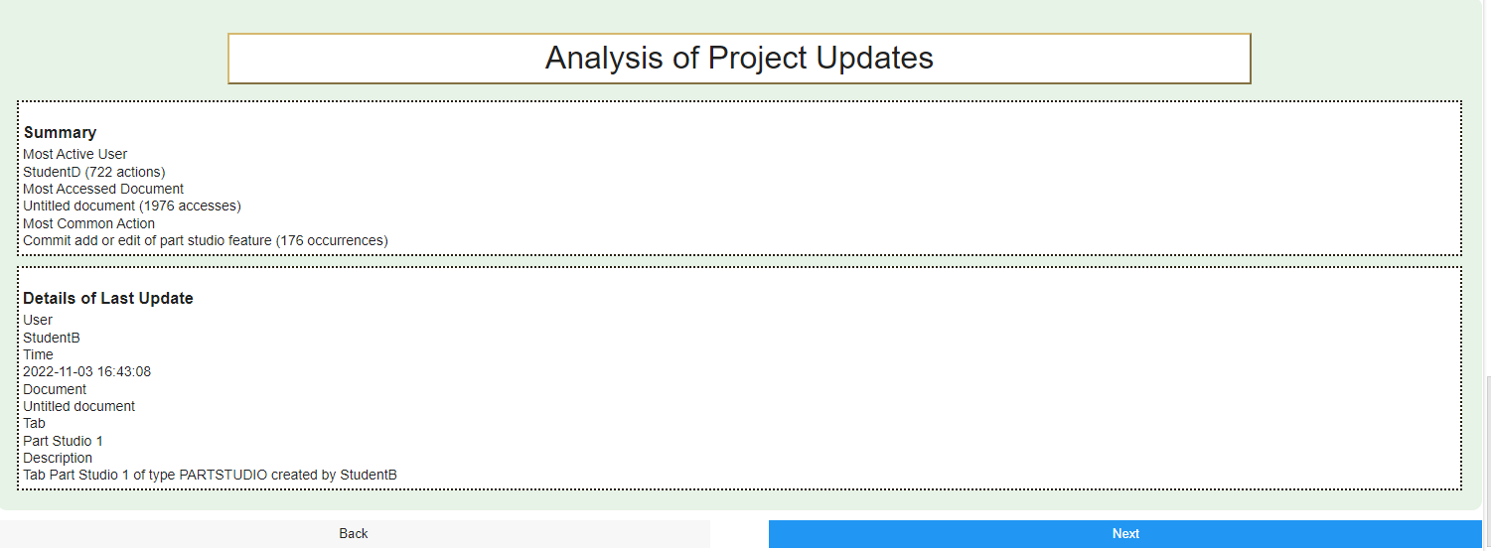

This interface which appears after clicking "Next" on the previous interface " Project Updates Interface Overview " provides an analysis of the project updates, summarizing key activities and offering detailed information about the most recent update.

Main Components:
- Summary Section:
  - Description: This section offers a high-level overview of project activity, including:
    - Most Active User: Identifies the student who has performed the most actions.
    - Most Accessed Document: Shows the document with the highest number of accesses.
    - Most Common Action: Highlights the most frequently performed action across the project.
  - How to Use:
    - Review this summary to quickly understand the key metrics and activities within the project.
    - Use this information to identify trends or focus areas, such as heavily accessed documents or frequently performed actions.
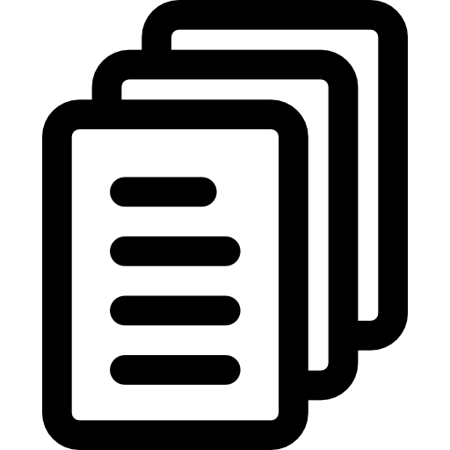
- Details of Last Update:
  - Description: This section provides specific details about the most recent update, including:
    - User: The student who performed the update.
    - Time: When the update was made.
    - Document: The document involved in the update.
    - Tab: The specific part or studio tab affected.
    - Description: A brief explanation of the update, detailing the changes made.
  - How to Use:
    - Review the details to understand the latest modification to the project.
    - This information is crucial for keeping track of ongoing changes and ensuring everyone is aware of the most recent developments.
- Navigation Buttons:
  - Back:
    - Function: Returns you to the previous "Project Updates" interface.
    - How to Use: Click this button if you need to go back to review the full list of recent updates or if you missed something in the earlier interface.
  - Next:
    - Function: Allows you to proceed to the next interface or section related to project updates.
    - How to Use: Click this button after reviewing the analysis to continue with the project workflow.

Instructions for Users:
- Reviewing the Summary:
  - Start by reading the summary section to get an overview of the project’s activity.
  - Pay special attention to the most active user, the most accessed document, and the most common action. These insights can help you understand the overall progress and focus areas.
- Understanding the Last Update:
  - Carefully review the details of the last update to stay informed about the most recent changes.
  - Note the user, time, document, and specific tab involved in the update, along with the description of what was changed or added.
- Navigating the Interface:
  - If you need to revisit the previous updates, use the "Back" button to return to the "Project Updates" interface.
  - Once you have reviewed the analysis, click "Next" to proceed to the next stage or section.

4-Data Visualization and Analysis Interface Overview
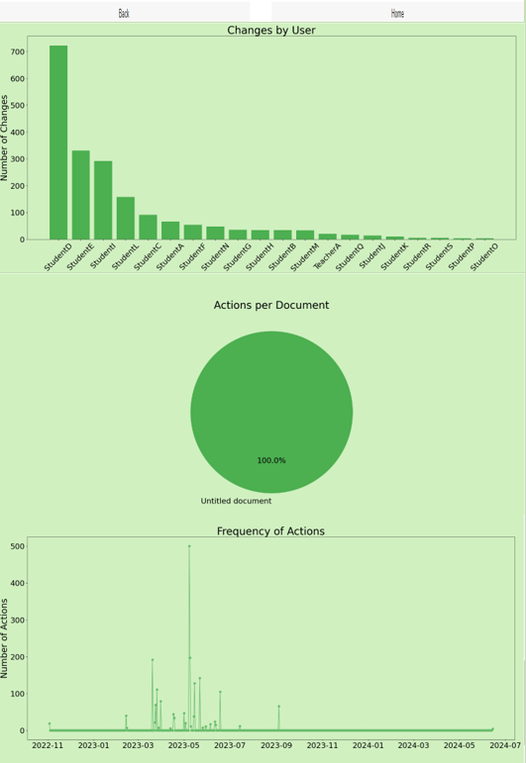
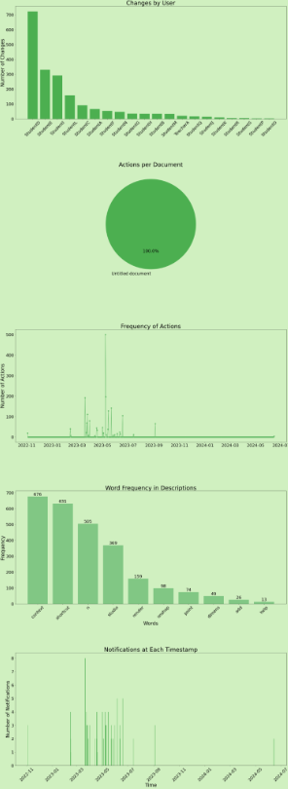

This interface appears when the user presses "Next" from the previous interface" Analysis of Project Updates Interface Overview " provides visual representations of the project's updates and actions, giving users insight into the project's progress and activity patterns. The charts help users analyze changes by user, actions per document, frequency of actions, word frequency in descriptions, and notifications at each timestamp.

Main Components:
- Navigation Buttons (Top of the Page):
  - Back:
    - Function: Returns you to the previous "Analysis of Project Updates" interface.
    - How to Use: Click this button if you need to go back to review the summary or detailed information from the previous analysis.
  - Home:
    - Function: Takes you back to the main interface of the application.
    - How to Use: Click this button to exit the analysis pages and return to the main menu.
- Graphs and Charts (Data Visualization):
  - Changes by User:
    - Description: This bar chart displays the number of changes made by each user, allowing you to identify the most active contributors.
    - How to Use: Analyze this chart to see which users have made the most changes, providing insight into individual contributions.

  - Actions per Document:
    - Description: This pie chart shows the distribution of actions across different documents, indicating which documents have been most frequently edited.
    - How to Use: Use this chart to understand the focus areas within the project, identifying key documents that have seen significant activity.
  - Frequency of Actions:
    - Description: This line chart illustrates the frequency of actions over time, highlighting periods of intense activity.
    - How to Use: Review this chart to see when the most work was done on the project, helping you correlate these peaks with project milestones or deadlines.
  - Word Frequency in Descriptions:
    - Description: This bar chart shows the frequency of specific words used in the descriptions of updates, providing insight into the common themes or focus areas.
    - How to Use: Analyze this chart to identify recurring terms in project descriptions, which can help in understanding the overall direction or focus of the project.
  - Notifications at Each Timestamp:
    - Description: This line chart tracks the number of notifications generated at different times, indicating when important updates or alerts were sent.
    - How to Use: Use this chart to see when notifications were most frequently sent, helping you track communication and alert patterns during the project's lifecycle.

Instructions for Users:
- Interpreting the Charts:
  - Begin by reviewing each chart to get an overall understanding of the project's activity.
  - Pay attention to the "Changes by User" chart to see who has been the most active in making updates.
  - Use the "Actions per Document" pie chart to identify the documents that have seen the most changes, which can highlight critical areas of focus.
  - The "Frequency of Actions" chart will help you understand the timeline of activity, showing when the most work was done.
  - Review the "Word Frequency in Descriptions" chart to see common themes or areas of focus in the project descriptions.
  - Finally, the "Notifications at Each Timestamp" chart gives you an overview of when alerts and updates were most frequently communicated.
- Navigating the Interface:
  - Use the "Back" button to return to the previous analysis page if you need to compare data or review earlier insights.
  - Click "Home" to exit the analysis section and return to the main menu, where you can access other features or start a new task.

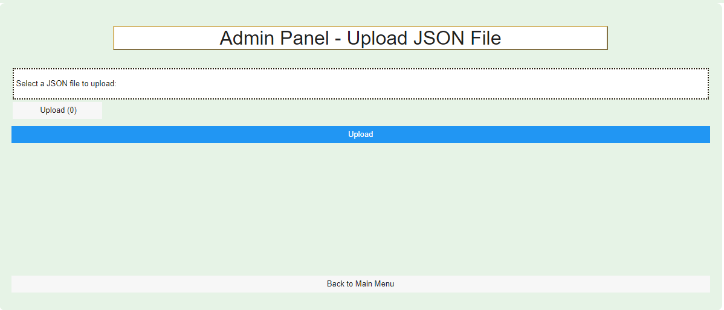
5- Admin Panel - Upload JSON File Interface Overview


This interface appears when the user clicks on the Admin Panel button from the main menu it allows users with administrative privileges to upload a JSON file to the system. This feature is crucial for managing and configuring data within the application.

Main Components:
- File Upload Section:
  - Description: This section provides the option to select a JSON file from your local system and upload it to the application.
  - How to Use:
    - Click on the Upload (0) button to open a file selector dialog.
    - Browse your computer to locate the appropriate JSON file.
    - Once selected, the file name will appear next to the button.
- Upload Button:
  - Description: This button initiates the upload process after a file has been selected.
  - How to Use:
    - After selecting the JSON file, click the Upload button to upload the file to the system.
    - Ensure that the file is in the correct JSON format to avoid any errors during the upload process.
    - After the upload is complete, you will receive a confirmation message indicating whether the upload was successful or if any issues occurred.
- Navigation Button:
  - Back to Main Menu:
    - Function: Returns you to the main menu interface from the admin panel.
    - How to Use: Click this button to exit the admin panel and go back to the main menu, where you can access other features or perform different tasks.

Instructions for Users:
- Uploading a JSON File:
  - Start by clicking the Upload (0) button to select the JSON file from your computer.
  - Once you've chosen the file, verify that the correct file name appears.
  - Click the Upload button to initiate the upload process. Ensure that the file is correctly formatted as a JSON file to prevent errors.
- Navigating Back:
  - If you decide not to upload a file or need to return to the main menu, click the Back to Main Menu button to navigate away from the admin panel.
- Important Notes:
  - Make sure you have administrative privileges to access this panel and upload files.
  - Double-check the JSON file content before uploading to avoid uploading incorrect or corrupt data.
  - If you encounter any issues during the upload, consult the system administrator for assistance.



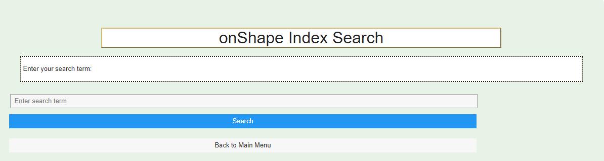
6- OneShape Index Search Interface Overview

This interface appears when the user clicks on the onShape Search button from the Main Menu page that allows users to perform a search within the onShape database, helping them locate specific information, designs, or documents based on the search term entered.

Main Components:
- Search Term Input Field:
  - Description: This field is where you enter the term or keyword you wish to search for within the onShape database.
  - How to Use:
    - Click inside the Enter search term box to activate the cursor.
    - Type in the keyword or phrase related to the information or design you are looking for.
    - Ensure the search term is specific enough to yield relevant results.
- Search Button:
  - Description: This button initiates the search based on the term entered in the input field.
  - How to Use:
    - After entering the search term, click the Search button to start the search process.
    - The system will then retrieve and display the results that match your search term.
    - If no results are found, consider using different or more specific search terms.
- Navigation Button:
  - Back to Main Menu:
    - Function: Returns you to the main menu interface from the onShape Index Search page.
    - How to Use: Click this button to exit the search interface and return to the main menu, where you can access other features or perform different tasks.

Instructions for Users:
- Conducting a Search:
  - Begin by entering a specific keyword or phrase into the Enter search term input field.
  - Make sure the term you enter is relevant to the information you are seeking in the onShape database.
  - Once your term is entered, click the Search button to initiate the search process.
- Reviewing Search Results:
  - After clicking Search, review the results that appear to find the most relevant information or design.
  - If the search does not yield the expected results, try refining your search term or using different keywords.
- Navigating Back:
  - If you wish to return to the main menu, click the Back to Main Menu button. This will take you out of the search interface and back to the main navigation hub.
- Tips for Effective Searching:
  - Use specific keywords rather than broad terms to increase the relevance of your search results.
  - If you don't find what you're looking for on the first attempt, try using synonyms or related terms.



7- Notification Settings/Personalization Interface Overview
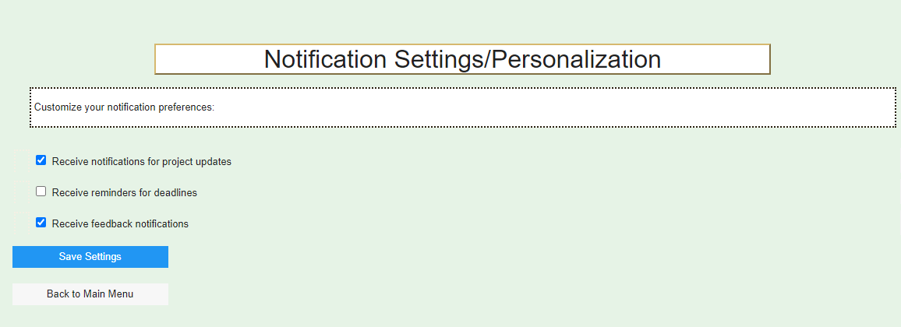

This interface appears when the user clicks on the Notification Settings button from the Main Menu it allows users to customize their notification preferences for the application. Users can choose which types of notifications they want to receive, helping them stay informed without being overwhelmed by unnecessary alerts.

Main Components:
- Notification Preferences:
  - Description: This section provides various options for users to select the types of notifications they wish to receive.
  - How to Use:
    - Receive notifications for project updates: Check this box if you want to receive notifications whenever there are updates related to projects. This is useful for staying informed about the latest changes and progress.
    - Receive reminders for deadlines: Check this box if you want to receive notifications reminding you of upcoming deadlines. This helps you stay on top of important dates and avoid missing any critical deadlines.
    - Receive feedback notifications: Check this box if you want to receive notifications whenever feedback is provided. This ensures you are promptly informed about any comments or suggestions made by others.
- Save Settings Button:
  - Description: This button saves your selected notification preferences.
  - How to Use:
    - After selecting your preferred notification options, click the Save Settings button to apply your choices.
    - A confirmation message will appear to let you know that your settings have been successfully saved.
- Navigation Button:
  - Back to Main Menu:
    - Function: Returns you to the main menu interface from the notification settings page.
    - How to Use: Click this button to exit the notification settings interface and return to the main menu, where you can access other features or perform different tasks.

Instructions for Users:
- Customizing Notifications:
  - Review each notification option and decide which alerts are most relevant to you.
  - Check the boxes for the notifications you want to receive. If you do not want to receive certain notifications, leave the box unchecked.
  - Ensure that your selections align with your preferences for staying informed about project updates, deadlines, and feedback.
- Saving Your Preferences:
  - Once you have selected your desired notification options, click the Save Settings button to confirm your choices.
  - Wait for the confirmation message to ensure that your settings have been successfully applied.
- Navigating Back:
  - If you wish to return to the main menu, click the Back to Main Menu button. This will take you out of the notification settings interface and back to the main navigation hub.

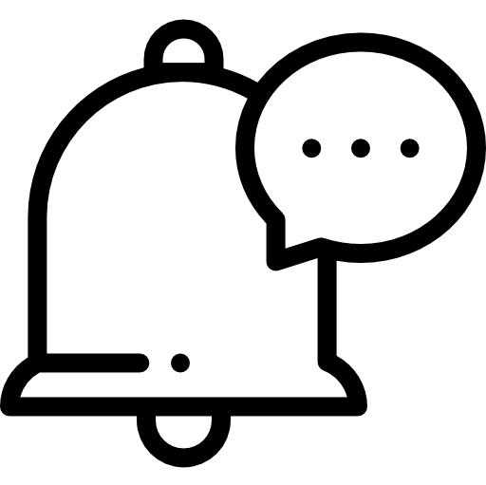

8- Recent Notifications Interface Overview
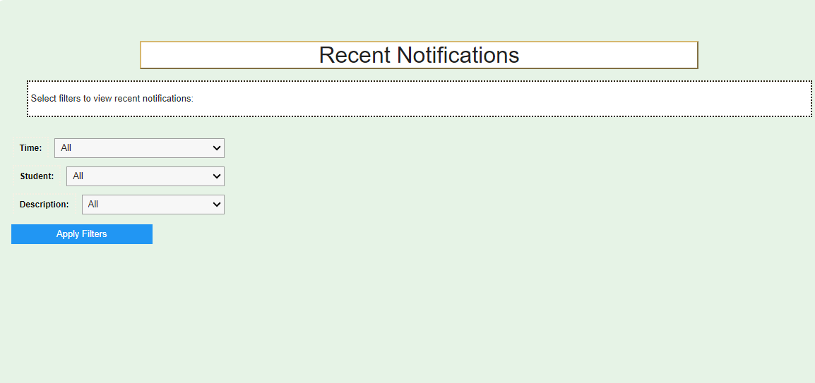

This interface appears when the user clicks on the Recent Notifications button from the Main Menu it allows users to filter and view recent notifications based on specific criteria such as time, student, and description. It helps users quickly find relevant notifications related to their projects or activities.

Main Components:
- Filter Options:
  - Time Filter:
    - Description: Allows you to filter notifications by the time they were received.
    - How to Use:
      - Use the dropdown menu to select a time frame (e.g., "Last 24 hours," "Last week," "All").
      - This filter helps you focus on notifications from a specific period.
  - Student Filter:
    - Description: Allows you to filter notifications based on the student who triggered them.
    - How to Use:
      - Select a specific student from the dropdown menu to view notifications related to their activities.
      - This is useful for tracking updates or actions taken by a particular student.
  - Description Filter:
    - Description: Allows you to filter notifications based on their description or type.
    - How to Use:
      - Choose a specific description from the dropdown menu to view notifications of a certain type (e.g., "Document update," "Deadline reminder").
      - This filter helps you find specific kinds of notifications quickly.
- Apply Filters Button:
  - Description: This button applies the selected filters and displays the relevant notifications.
  - How to Use:
    - After selecting the desired filters (time, student, and/or description), click the Apply Filters button to view the filtered notifications.
    - The system will display notifications that match the selected criteria, making it easier to find the information you need.
- Navigation Button:
  - Back to Main Menu:
    - Function: Returns you to the main menu interface from the recent notifications page.
    - How to Use: Click this button to exit the notifications interface and return to the main menu, where you can access other features or perform different tasks.

Instructions for Users:
- Filtering Notifications:
  - Start by selecting the filters that are most relevant to you. For example, if you want to see all notifications from the last week related to a specific student, adjust the Time and Student filters accordingly.
  - Use the Description filter to narrow down notifications to specific types, such as updates or reminders.
- Applying Filters:
  - After setting your desired filters, click the Apply Filters button to display the matching notifications.
  - Review the filtered notifications to find the specific updates or alerts you're looking for.
- Navigating Back:
  - If you wish to return to the main menu, click the Back to Main Menu button. This will take you out of the notifications interface and back to the main navigation hub.
- Tips for Effective Use:
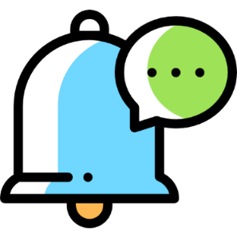
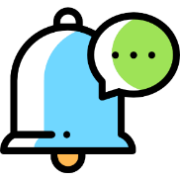
  - Use multiple filters together for more specific results, such as filtering by both time and student.
  - If no notifications are found, try adjusting the filters to broaden the search criteria.

9- Project Management Chatbot Interface Overview
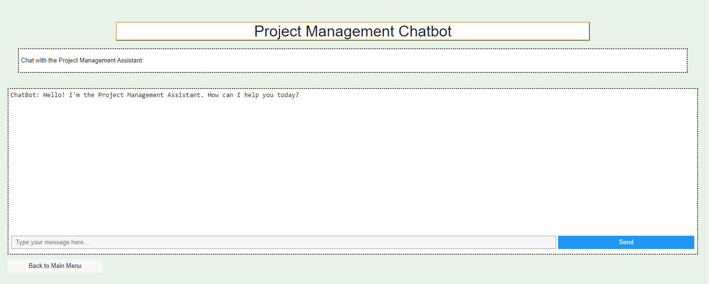

This interface appears when the user clicks on the Chatbot button from the Main Menu it allows users to interact with a chatbot designed to assist with project management tasks. The chatbot can answer questions, provide guidance, and help with various project-related activities.

Main Components:
- Chat Window:
  - Description: The central area where the conversation with the chatbot takes place. This is where you will see the chatbot's responses and where your messages will appear.
  - How to Use:
    - Read the chatbot's greeting and any instructions it provides.
    - The chatbot is ready to assist with project management queries, such as checking updates, deadlines, or providing guidance on using different features.
- Message Input Field:
  - Description: The text box located at the bottom of the chat window where you can type your messages or questions to the chatbot.
  - How to Use:
    - Click inside the Type your message here... box to activate the cursor.
    - Type your question or request for assistance. Be as specific as possible to help the chatbot understand your needs.
    - After typing your message, press the Enter key or click the Send button to submit your message to the chatbot.
- Send Button:
  - Description: This button sends your typed message to the chatbot for a response.
  - How to Use:
    - After entering your message in the input field, click the Send button to submit it.
    - The chatbot will then process your request and provide a response in the chat window.
- Navigation Button:
  - Back to Main Menu:
    - Function: Returns you to the main menu interface from the chatbot page.
    - How to Use: Click this button to exit the chatbot interface and return to the main menu, where you can access other features or perform different tasks.

Instructions for Users:
- Interacting with the Chatbot:
  - Start by reading the initial message from the chatbot. It will often greet you and ask how it can assist.
  - Type your question or request in the message input field. For example, you might ask, "What are the latest project updates?" or "How do I upload a JSON file?"
  - Be clear and specific in your messages to ensure the chatbot can provide accurate assistance.
- Sending Messages:
  - After typing your message, click the Send button or press Enter to submit it.
  - The chatbot will respond based on the information it has, and you can continue the conversation as needed.
- Navigating Back:
  - If you wish to return to the main menu, click the Back to Main Menu button. This will take you out of the chatbot interface and back to the main navigation hub.
- Using the Chatbot Effectively:
  - If you’re unsure about what the chatbot can do, ask it general questions like "What can you help me with?" to get a list of possible tasks it can assist with.
  - Use the chatbot as a quick resource for guidance on project management tasks or to get answers to specific questions without needing to navigate through the entire system.


10-Common Errors and Troubleshooting

1. Entering Incorrect Data

Potential Misuse: If you enter incorrect or incomplete data, such as a wrong project ID or missing information, the system may not behave as expected. This could lead to errors in data processing or inaccurate outputs.

How to Avoid: Always double-check the data you enter. The system includes input validation, which will prompt you if something seems off. Pay attention to these prompts and make the necessary corrections before proceeding. If you're unsure about what information is required, refer to the on-screen instructions or contact support for clarification.

2. Navigating the Interface Incorrectly

Potential Misuse: It’s easy to accidentally click the wrong button or navigate to the wrong screen, which might cause you to lose track of where you are or even lose unsaved work.

How to Avoid: Take your time to familiarize yourself with the navigation layout. Each button is clearly labeled, and there are confirmation prompts before any critical actions, like leaving a page with unsaved changes. If you do make a wrong turn, the “Back” button will always help you return to the previous screen. Also, consider using the breadcrumb navigation to keep track of your path.

3. Uploading the Wrong File

Potential Misuse: Uploading an incorrect or incompatible file, such as a corrupted JSON file, can cause the system to throw errors or fail to process the data.

How to Avoid: Before uploading, ensure the file is in the correct format (e.g., JSON) and is not corrupted. The system will alert you if the file format is incorrect, but it’s always good practice to verify your file beforehand. If the upload fails, don’t hesitate to recheck the file and try again.

4. Misconfiguring Notification Settings

Potential Misuse: If you misconfigure your notification settings, you might end up missing important updates or receiving too many notifications, which can be overwhelming.

How to Avoid: Start by using the default settings, which are designed to suit most users. If you need to customize them, take your time to review each option and understand how it affects your notifications. There’s an option to preview how notifications will appear based on your settings, which can help you fine-tune your preferences. If you’re not happy with your changes, you can always reset to the default settings.

